# **Internship Status Update**

* Week 1 - (19.02 - 23.02):
  + Set up my work and organisation (Notion) environment
  + Started writing my Project Plan
  + Created a Breakdown of the project
  + Visualised the plan in a Gantt chart
  + A close-up of a project

    Description automatically generatedA close-up of a calendar

    Description automatically generatedCame up with research questions
* Week 2 (26.02 - 01.03)
* Project Plan first draft was reviewed from the company mentor and sent for feedback from Fontys mentor
* Researched: Data Visualisation Trends, Popular tools and platforms used for data visualisation, The benefits and limitations of AI forecasting for decision-making processes
* LinkedIn Learning course for Interaction Design: Dashboards and Visualization
* Project kick-off meeting with Tada and Bankai company mentors - got introduced to the company project Live Blueprints, and insights on the design they are working on.
* Side task: Did a rebrand of a brochure for the company in Canva
* Week 3 - (4.03 - 10.03)
* Side task: Rebrand LinkedIn and white paper materials for company's client.
* Research topics:
  + **AI Forecasting Techniques:**
    - Understand the benefits and limitations of AI forecasting for decision-making processes.
    - What information could be predicted?
    - Implementation
    - What problems the AI could find?
    - What solutions the AI could suggest?
  + **Dashboard Design**
    - Key Characteristics of Great Dashboards
  + **Component design system**
  + **Data Visualisation Trends:**
    - Explore current trends in data visualisation across various industries.
    - Identify popular tools and platforms used for data visualisation.
    - Current data visualisation Tada Solutions is using
* Finalised the Initial Background Research and combined it into one PDF file.
* 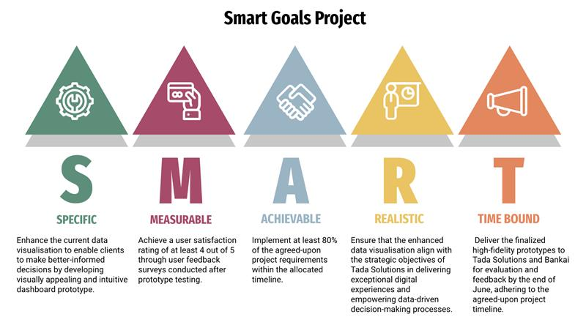Wrote projects SMART Goals -  Answering one of my research subquestions: "How can the effectiveness of improved data visualisation be measured and evaluated?"

Week 4 – (11.03 - 15.03)

* Side task: Rebrand CJM materials for company's client.
* Investigated different departments and the connection between them
* Created a flowchart for deeper understanding of the data flow between departments
* Created inspiration moodboard

Week 5 - (18.03 - 24.03)

* Side tasks: document improvements of the website ([https://www.schulinck.nl](https://www.schulinck.nl/))
* Side task: create a infographic for client Kwint
* Created a FigJam for brainstorming
* Investigated Possible metrics for different departments dashboards
* Looked for possible KPI for each department
* Added inspiration images of KPI visualisation

Week 6 - (26.03 - 29.03)

* Side task: Create a flowchart for Bouwend departments data flow
* Alter Department DataFlow Flowchart based on feedback. (Added Production department)
* Investigate where exactly can problems regarding data flow can occur
* Wireframing on paper
* Started wireframing in Figma

Week 7 - (01.04 - 05.04)

* Continued wireframing
* Started the Portfolio website
* Created a basic structure of the Portfolio
* Organised documents in Notion
* Visualise some ideas within the wireframe and ask for feedback (widgets, dataflowchart, structure)

Week 8 - (08.04 - 12.04)

* Wire-framing
* Portfolio website development
* Started writing Research Document

Week 9 - (15.04 - 19.04)

* MidTerm Review Presentation
* Feedback from Jos: validating features through LinkedIn Post
* Career Day: next semester choice of advanced media design
* Feedback on wireframe and Project from Metaxas and Li:
  + Prioritise features as soon as possible
  + Leave AI forecasting implementation
  + Ask for possible data

Week 10 - (22.04 - 26.04)

* Finished Portfolio Template
* Continue writing Research Document
* Created a possible LinkedIn post for prioritising features
* Meeting with Thijn
* Feedback on wireframe

Week 11 - (29.04 - 03.05)

* Started Final Prototype
* Researched on suitable colors
* Tested ways of creating interactive menu navigation bar
* Finished Style Guide
* Started designing the charts as components

Week 12 - (6.05 - 10.05)

* Finished the chart
* Finished the grid
* Finished side bar navigation
* Researched on how to create a visual hierarchy in dashboard
* Portfolio progress

Week 13 - (13.05-17.05)

* Interview expert on Marketing department processes
* Meeting regarding operational efficiency (PEP & EIP) with Bankai
* Started on departments overview page (Final Prototype)
* Portfolio progress

Week 14 - (20.05-24.05)

* Created two variants of visual for the metrics overview page
* Updated the user journey flow
* Conducted 3 User Testings
* Started writing User Testing Report

Week 15,16,17,18 - (27.05-18.06)

* Writing Internship Report
* Updating Git Wiki Portfolio